## Visualisation 1

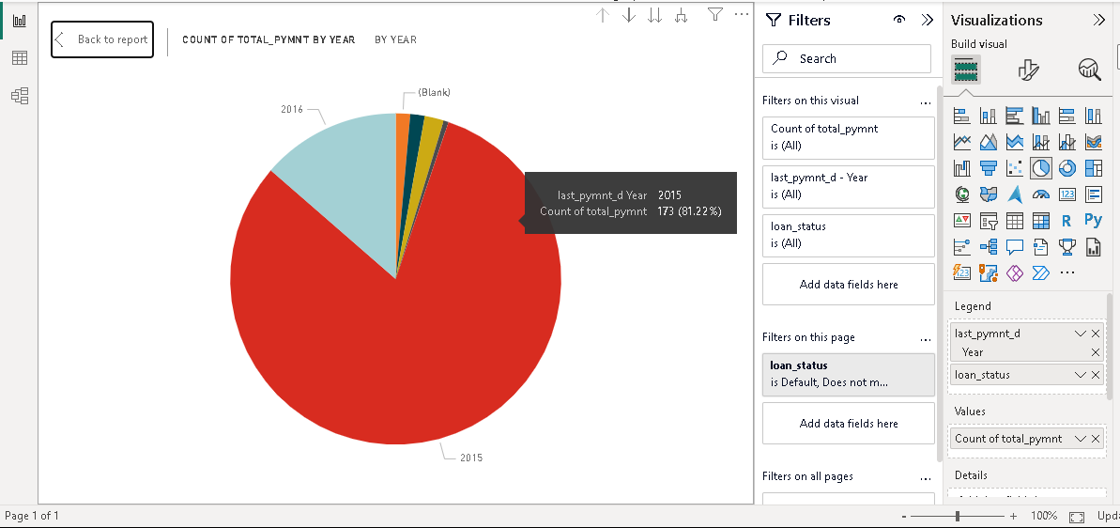

Figure 20 pie chart visualization

In the first visualization of the following report, the pie chart is made to describe the total payment by year. It means what Is the total payment submitted by the customer every year. The chart has divided the circle into various parts, and each part shows the total payment year-wise. The pie chart shows that in the year 2015, the total payment made by the defaulters was 173, and that is the maximum amount of the total payment done in any year. The second maximum amount is for the year 2016, and the other year shown in the area chart is very small. (Sheldon and Lyubomirsky, 2019).

## Visualization 2

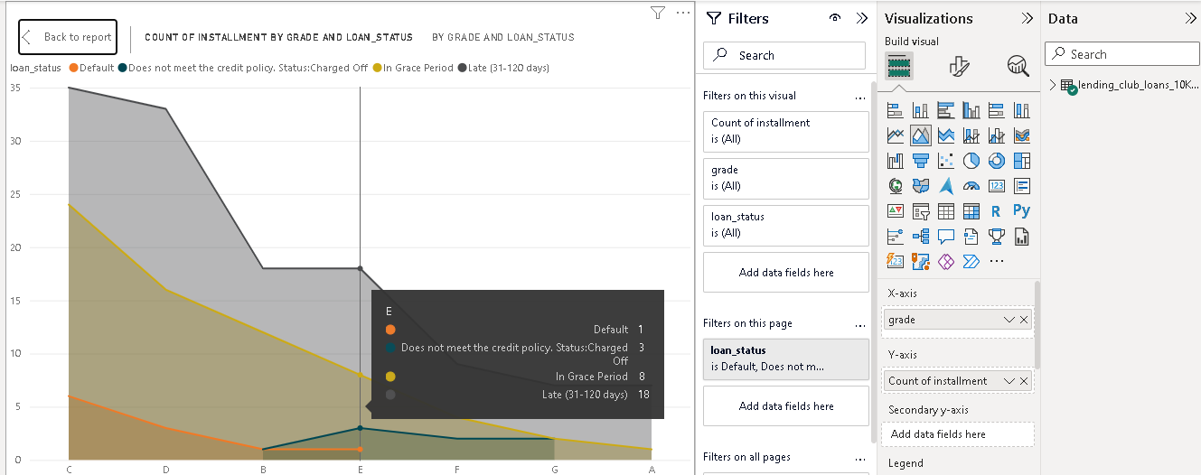

Figure 18 area chart visualization

In the second visualization of the following report, the area chart is made to describe the instalment by grade and loan status. It means the instalment submitted by the defaulted customer for every grade. The chart has divided the area into various regions, and each region shows the total instalment grade-wise. The area chart shows that in grade C, the total number of instalments made by the defaulters was 35, and that is the maximum amount of the total instalment done in any grade. The second maximum instalment is for grade D, and the other grades shown in the area chart are smaller than these two grades (Adamian et al., 2020).

## Visualization 3

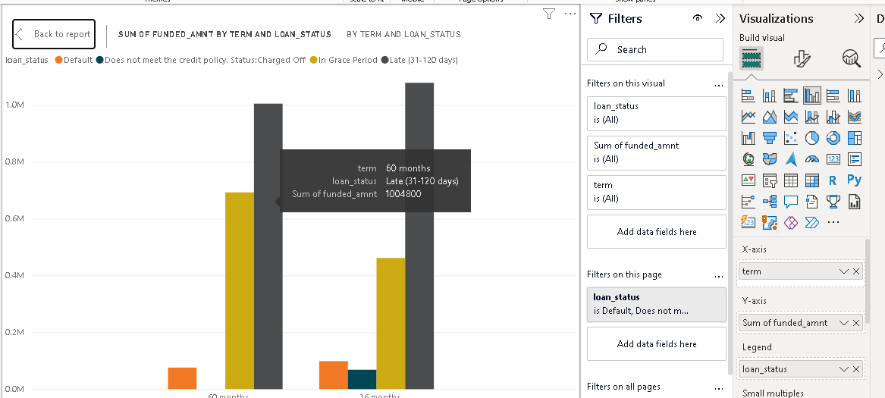

Figure 19 bar graph visualization

In the third visualization of the following report, the bar chart is made to describe the funded amount in each term on the basis of loan status. It means the funded amount submitted by the defaulted customer for each term. The chart has divided the blocks into two regions, and each region shows the term for 36 and 60 months. The area chart shows that in the term 36 months, the total funded amount made by the defaulters was more than 60 months. There is a slight difference in the numbers of the visualization, which is due to the charged-off status-wise credit policy of loan defaulted status. (Midway, 2020).

## Insight of the visualisation

The visualizations tell that in the ongoing season, the money from defaulters has reached the organization. In the initial years, they did not deposit money, but in recent years, they have deposited the money, which is a good sign for the organization. These visualizations tell that in grades C and D, the money from defaulters has reached the organization. In the other grades, they did not deposit money, but in the coming years, they will deposit money in such grades, too, which is a good sign for the organization. These visualizations tell that in term 36 months, the money from defaulters has reached the organization. In other words, they deposit less money, which means that in a certain time period, the defaulters submit money, which is a good sign for the organization. They did not wait for more time period.